Coding Assignment 5

Fetch And Paginate Data (120:00)

#### **Learning Outcome Addressed**

 9.Use React to fetch, manipulate, and render data

**Fetching Data**

### React – Get Data

Now, it's time to practice getting data from the MIT [Hacker News](https://thehackernews.com/) remote data source. In the first step of this activity you'll add code that fetches the Hacker News data, as well as add new styles to the list of articles. Then, in the second step, you'll add client-side pagination to display data on multiple pages.

[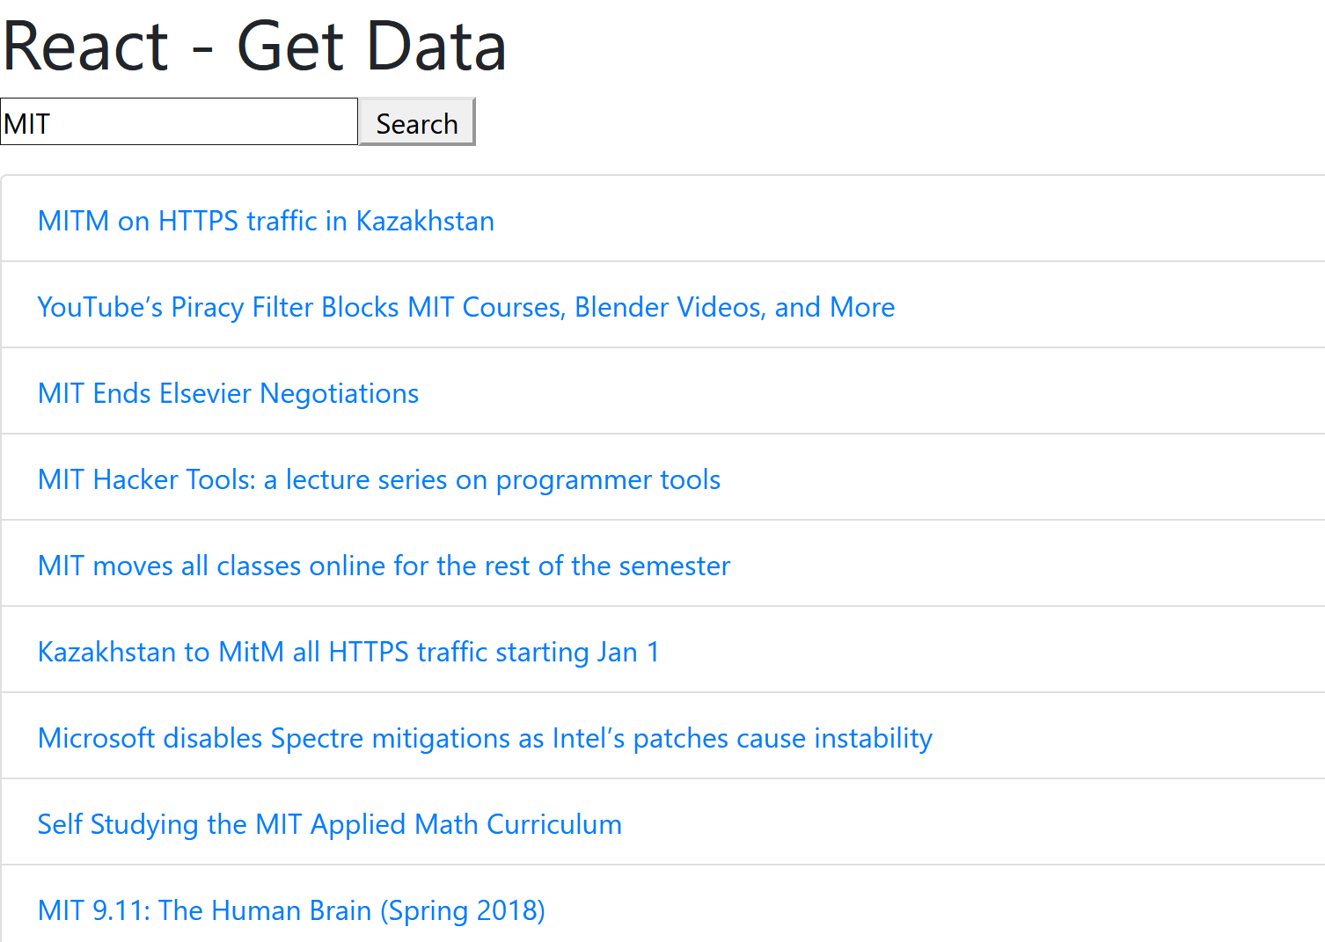](https://cdn.filestackcontent.com/QzYUcMaERtKRI5pqgDeq)